- Gather your materials. This experiment will allow you to create a light pinhole, which will show you how light travels in a straight line by filtering it through a hole. To create a light pinhole, you will need the following supplies;
- Three index cards.
- A piece of blu tac or you can also use double sided tape.
- A flashlight, a laser pointer or the torch function on a phone.
- A hole puncher or scissors.
- A ruler

- Punch a hole in the centre of the cards. To do this without any excessive measuring, use the ruler to draw two diagonal lines on a card that connect the opposite corners of the card. Repeat this for the other two cards.
- Take the hole puncher or scissors and punch a hole at the centre of the card where the two lines intersect. Do this for the other two cards.

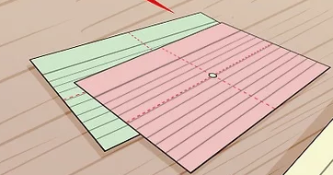

- Use the modelling clay to stand up the cards. The cards need to stand vertically, at equal distance from each other, and in a straight line for this experiment to work.
- Form a stand for the cards using the clay so the cards are straight and upright. Use the ruler to ensure the cards are two to five inches from each other.
- You can also use double sided tape to attach the cards to a surface in a vertical position. Do not cover or obstruct the hole in the centre of the cards with blu tac or tape.
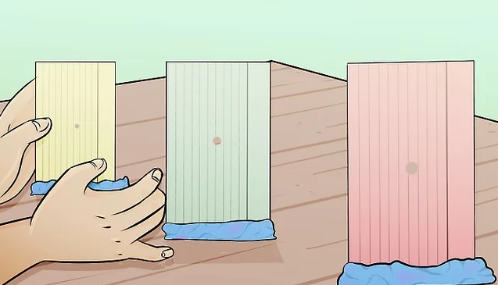What happens if the cards are not in a straight line?
- Position the flashlight, laser pointer or the torch on your phone at one end of the row of cards. Hold the flashlight in your hand so it hits the centre of the hole in the first card. Turn on the flashlight, laser pointer or torch on your phone.
- Note that the light can be seen through all the holes. You should be able to see the light go through all the holes and land on a wall or surface beyond the last card.

