Purple and Yellow group Maths 23/0420
LO: I can double numbers to 5.
Double ______ is _____
Double ______ is _____

Double ______ is _____

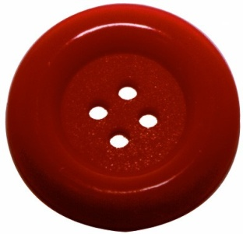
Double ______ is _____

**Challenge – Can you use an example to write a number sentence?
Please send marked screen shot work to pjones@kingsavenue.lambeth.sch.uk Thank you

