WEEK 4 - Maths

A reminder
For the Maths lesson every day you should practice your times tables then start the maths lesson.

Each maths lesson there is a video clip for you to watch, questions, answers and a challenge. You can watch the video clip more than once if you are unsure of anything. Sometimes the video will ask you to pause it to complete some questions. You do not have to print off the sheet, you can record your answers on anything you have available e.g. paper, chalk board, whiteboard. When you have finished the questions, get an adult to check your answers from the answers provided.

Multiplication
Continue to learn the 8 times table.
https://www.youtube.com/watch?v=dSnNkgMbtfs

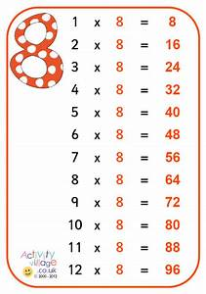

MATHS LESSON - SUMMER TERM MATHS – week 2 w/c 27th April

We will be doing this unit this week. It looks like this
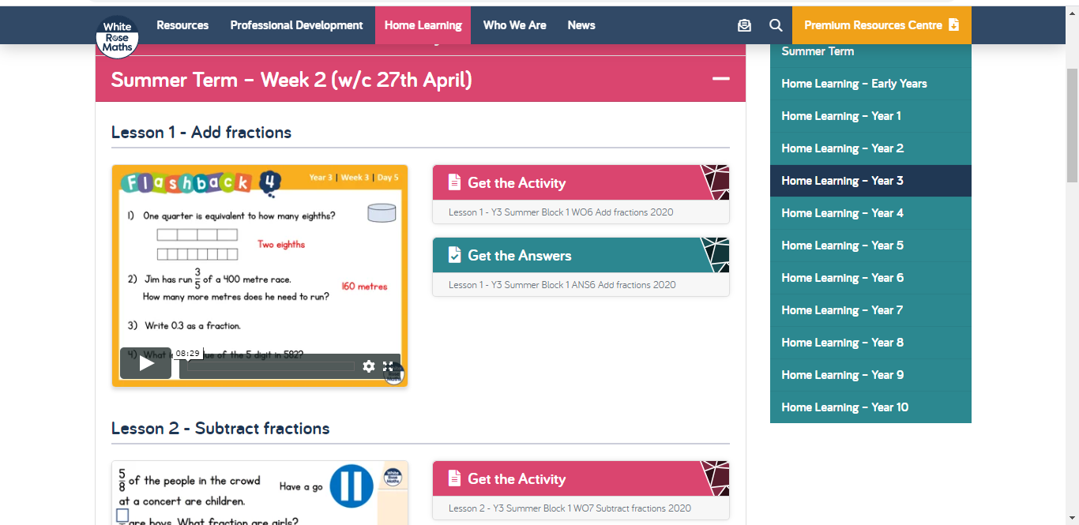

Watch the video every day as it will explain the learning for the day.
https://whiterosemaths.com/homelearning/year-3/

Monday – lesson 1
Tuesday – lesson 2
Wednesday – lesson 3
Thursday – lesson 4
FRIDAY – THERE IS NOT A VIDEO CLIP

Let me know how you get on and send your work or an image of your work. You can email me at: jclarke@kingsavenue.lambeth.sch.uk

I look forward to hearing from you.

Ms. Clarke

