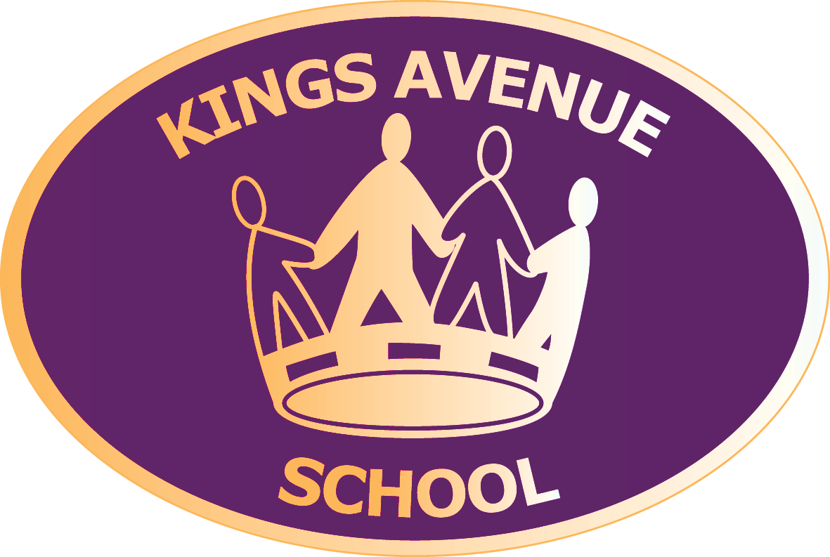 | 2s Weekly Spelling Words  Week 4
Look... | Say... | Cover... | Write... | Check...
written | written | written
wrote | wrote | wrote
wrong | wrong | wrong
wrap | wrap | wrap
gnat | gnat | gnat
gnaw | gnaw | gnaw
knee | knee | knee
know | know | know
knock | knock | knock
How can you practise at home? | Flower  Words | Write each spelling word in a different colour or font | Make a word find with your spelling words | Write each word into an AMAZING sentence

Weekly times table practice

Let’s keep practicing our 4 times table!

0 x 4 = 0 | 0 x 4 = | 0 x 4 =
1 x 4 = 4 | 1 x 4 = | 1 x _ = 4
2 x 4 = 8 | 2 x 4 = | _ x 4 = 8
3 x 4 = 12 | 3 x 4 = | 3 x 4 =
4 x 4 = 16 | 4 x 4 = | 4 x 4 =
5 x 4 = 20 | 5 x 4 = | 5 x _ = 20
6 x 4 = 24 | 6 x 4 = | 6 x _ = 24
7 x 4 = 28 | 7 x 4 = | _ x 4 = 28
8 x 4 = 32 | 8 x 4 = | 8 x 4 =
9 x 4 = 36 | 9 x 4 = | 9 x _ = 36
10 x 4 = 40 | 10 x 4 = | 10 x 4 =
11 x 4 = 44 | 11 x 4 = | __ x 4 = 44
12 x 4 = 48 | 12 x 4 = | 12 x 4 =

2s Weekly Spelling and Times Tables Tests
Week 4
Spelling Test |  | Times Tables Test
1 |  | 1
2 |  | 2
3 |  | 3
4 |  | 4
5 |  | 5
6 |  | 6
7 |  | 7
8 |  | 8
9 |  | 9
10 |  | 10
 |  | 11
 |  | 12

/10 | /12

